**Unit-3**

**Business Applications of Information Technology**

**E-Commerce and Internet**

**E-commerce**

E-Commerce is characterized by Business Business and Business to Customer business models. We are very familiar with the Business to Customer model for banking; insurance as well as online shopping, online booking, etc that have become very popular and accepted modes in our daily lives. On the B to B front too, business organizations have re-engineered their Business processes including Advertising, Marketing, Sales Order Management besides Supply chain management and Customer Relationship management to suit the E-Commerce mode. Dell has successfully adapted the ‘online selling’ model on a global scale. It allows the customers to ‘configure the model’ and to ‘Order Online. Once the transaction has been successfully carried out and payment has been received, Dell executes the order and ensures that the Dell Products are delivered to the Customer’s doorstep within seven working days

**Benefits of E-Commerce**

* First and foremost internet being a world wide web, opens up the world as a market to businesses. Businesses can reach out to millions of customers in an instant which is not possible in any conventional mode of marketing
* The cost of marketing online across the globe is minuscule when compared to the actual cost of marketing in the conventional ways and the cost per transaction works out to be very cheap.
* Online financial transaction capability has given a significant push to E-Commerce. E-commerce has not only caught the imagination of B to B and B to C businesses but today we have online trading which has perhaps changed the way stock markets, financial markets, and commodity exchanges across the world function.

**E-Commerce related Technologies**

Most Organisations keep their E-Commerce and internet-related IT infrastructure separate from the internal Company servers and information. The World Wide Web is truly an open highway where any information that is available on the server can be accessed by anyone through search mechanisms. Moreover, there are several tools available on the internet that can be used by hackers to steal information from your site, divert traffic from your mail systems, and play havoc with your website. Organizations would not wish to keep all information open to one and all.

We have seen the development of 2G, 3G,4G technologies available through cable, satellite, Wi-Fi modes connecting not only to the Computers but to a host of other handheld devices such as mobile smartphones, tablets, etc. Today the connectivity-related infrastructure has merged voice| telephone, data as well as video, and the service providers are vying with one another to dominate the endpoint to serviceability to individual customers as integrated service providers.

**Intranet, Extranet, and Enterprise Solutions**

**Intranet and Extranet:-**

An Intranet is a private network used by employees to communicate and collaborate. They can also use the company intranet to create content, complete their work, and engage in the company culture. The intranet can be cloud-based, hosted on-site, or on off-site servers. The first intranets came into use during the 1990s.

An Extranet is a private network too. It works similarly to a company intranet; however an extranet allows access to authorized users from outside the company. These external users may include suppliers and partners. It can be shared by more than one organization, such as a business that allows its vendors to access the company extranet for product and billing purposes.

**Similarities between intranet and extranet**

Both allow organizations to share documents(especially large ones), calendars, and projects in a single location. Intranet and Extranets also make it easier for customers, partners, and remote workers to collaborate.

**Difference between Intranet and Extranet**

An Intranet is typically accessed through a cloud-based portal. Administrators assign a login, password, and permissions to employees. Once the employees are given access, they can communicate with co-workers, managers, and executives, the employee also has access to forms, documents, and company manuals within the scope of their permissions.

An Extranet is accessed by authorized users through a secure, web-based login. It allows the clients, vendors, or suppliers to communicate with a business’s employees. The extranet only allows these authorized users to have limited access to the business’s documents and files.

For example, a supplier would be able to access their invoices and securely share product information with a manufacturing business. The supplier will also be able to communicate with the company’s customer service representatives and accounting staff.

**Benefits of an Intranet:-**

1. Boosts employee productivity:- the intranet software suite of knowledge sharing and collaboration tools makes it easier and more convenient for employees to accomplish tasks.

2. Creates a transparent company culture:- it is more important than ever that employees feel comfortable at work. When they can share their ideas and opinions.

3. Streamlines employee onboarding:- new employee forms and onboarding material can be presented to the new team member in a neat package through the company intranet.

4. Connects the company across multiple locations:- the company intranet is the central hub for the business. It connects employees working in the home office, as well as satellite offices.

5. Helps employees find information quickly:- a global search feature makes finding information using intranet a quick and easy process.

Example:- Schnuck markets: supermarket chain

An extranet is accessed by authorized users through a secure, web-based login. It allows the clients, vendors, or suppliers to communicate with a business’s employees, The extranet only allows these authorized users to have limited access to the business’s documents and files.

**Benefits of an Extranet:-**

1. Reduce errors:-An extranet allows a company to give specific groups access to specific information. Everyone has access to the same information, which reduces the likelihood of communication errors.

2. Efficient information sharing:- An extranet provides information access for key players, especially if it is time-sensitive. Price lists, special discounts, sales are examples of items that may need to be communicated quickly.

3. Increase customer loyalty:- Extranets allow customers to review their orders, get information about products and connect with customer service representatives.

4. Documents are secure:- Documents and information uploaded to the extranet are kept safe. They cannot be accessed by anyone without proper permission and credentials.

5. Setup is easy:- Modern extranets need little to no help from a company’s IT department to set up. These extranets are generally cloud-based and user-friendly, With an easy-to-use platform, the modern version is more economical too.

Example:- Manufacturing, Healthcare

**Enterprise Solutions:**

Enterprise solutions are designed to integrate multiple facets of a company’s business through the interchange of information from various business process areas and related databases. This solution enables companies to retrieve and disseminate mission-critical data throughout the organizations, providing managers with real-time operating systems

**INFORMATION SYSTEM FOR BUSINESS OPERATION.**

**What is Management Information Systems (MIS)?**

A management information system (MIS) is a computer system consisting of hardware and software that serves as the backbone of an organization’s operations. An MIS gathers data from multiple online systems, analyzes the information, and reports data to aid in management decision-making.

MIS is also the study of how such systems work.

**Improved Decision-Making**

The purpose of an MIS is to improve decision-making, by providing up-to-date, accurate data on a variety of organizational assets, including:

• Financials

• Inventory

• Personnel

• Project timelines

• Manufacturing

• Real estate

• Marketing

• Raw materials

• R&D

The MIS collects the data, stores it, and makes it accessible to managers who want to analyze the data by running reports.

**Central Information System**

The goal of an MIS is to be able to correlate multiple data points in order to strategize ways to improve operations. For example, being able to compare sales this month to sales a year ago by looking at staffing levels may point to ways to boost revenue. Or being able to compare marketing expenditures by geographic location and link them to sales can also improve decision-making. But the only way this level of analysis is possible is due to data that is compiled through an MIS.

Running reports that pull together disparate data points is an MIS’ key contribution. That feature, however, comes with a significant cost. MIS implementation is an expensive investment that includes the hardware and software purchases, as well as the integration with existing systems and training of all employees.

**Information System for Managerial support system (DSS)?**

A decision support system (DSS) is a computer program application used to improve a company's decision-making capabilities. It analyses large amounts of data and presents an organization with the best possible options available.

Decision support systems bring together data and knowledge from different areas and sources to provide users with information beyond the usual reports and summaries. This is intended to help people make informed decisions.

Typical information a decision support application might gather and present include the following:

• comparative sales figures between one week and the next;

• projected revenue figures based on new product sales assumptions; and

• the consequences of different decisions.

A decision support system is an informational application as opposed to an operational application. Informational applications provide users with relevant information based on a variety of data sources to support better-informed decision-making. Operational applications, by contrast, record the details of business transactions, including the data required for the decision-support needs of a business.

**Decision support system components**

A typical DSS consists of three different parts: knowledge database, software, and user interface.

**Knowledge base:-** A knowledge base is an integral part of a decision support system database, containing information from both internal and external sources. It is a library of information related to particular subjects and is the part of a DSS that stores information used by the system's reasoning engine to determine a course of action.

.

**Software system:-** The software system is composed of model management systems. A model is a simulation of a real-world system with the goal of understanding how the system works and how it can be improved. Organizations use models to predict how outcomes will change with different adjustments to the system.

**For example,** models can be helpful for understanding systems that are too complicated, too expensive, or too dangerous to fully explore in real life. That's the idea behind computer simulations used for scientific research, engineering tests, weather forecasting, and many other applications.

Models can also be used to represent and explore systems that don't yet exist, like a proposed new technology, a planned factory, or a business's supply chain. Businesses also use models to predict the outcomes of different changes to a system -- such as policies, risks, and regulations -- to help make business decisions.

**User interface:-** The user interface enables easy system navigation. The primary goal of the decision support system's user interface is to make it easy for the user to manipulate the data that is stored on it. Businesses can use the interface to evaluate the effectiveness of DSS transactions for the end-users. DSS interfaces include simple windows, complex menu-driven interfaces, and command-line interfaces.

**Intelligent decision support system (IDSS)**

Users can also bake artificial intelligence (AI) into decision support systems. Called intelligent decision support systems (IDSS), the AI mines and processes large amounts of data to get insights and make recommendations for better decision-making. It does this by analyzing multiple sources of data and identifying patterns, trends, and associations to emulate human decision-making capabilities.

Designed to act similar to a human consultant, an IDSS gathers and analyzes data to support decision-makers by identifying and troubleshooting issues and providing and evaluating possible solutions. The AI component of the DSS emulates human capabilities as close as possible, while more efficient processing and analyzing information as a computer system.

The IDSS may include advanced capabilities such as a knowledge base, machine learning, data mining and a user interface. Examples of IDSS implementations include flexible or smart manufacturing systems, intelligent marketing decision support systems, and medical diagnostic systems.

Different kinds of decision support systems can improve a company's decision-making capabilities in a variety of areas.

**Types of decision support systems**

Decision support systems can be broken down into categories, each based on their primary sources of information.

**Data-driven DSS**

A data-driven DSS is a computer program that makes decisions based on data from internal databases or external databases. Typically, a data-driven DSS uses data mining techniques to discern trends and patterns, enabling it to predict future events. Businesses often use data-driven DSSes to help make decisions about inventory, sales, and other business processes. Some are used to help make decisions in the public sector, such as predicting the likelihood of future criminal behavior.

**Model-driven DSS**

Built on an underlying decision model, model-driven decision support systems are customized according to a predefined set of user requirements to help analyze different scenarios that meet these requirements. For example, a model-driven DSS may assist with scheduling or developing financial statements.

**Communication-driven and group DSS**

A communication-driven and group decision support system uses a variety of communication tools -- such as email, instant messaging, or voice chat -- to allow more than one person to work on the same task. The goal behind this type of DSS is to increase collaboration between the users and the system and to improve the overall efficiency and effectiveness of the system.

**Knowledge-driven DSS**

In this type of decision support system, the data that drives the system resides in a knowledge base that is continuously updated and maintained by a knowledge management system. A knowledge-driven DSS provides information to users that is consistent with a company's business processes and knowledge.

**Document-driven DSS**

A document-driven DSS is a type of information management system that uses documents to retrieve data. Document-driven DSS enables users to search web pages or databases or find specific search terms. Examples of documents accessed by a document-driven DSS include policies and procedures, meeting minutes, and corporate records.

Acknowledge base is an integral part of a knowledge-based decision support system.

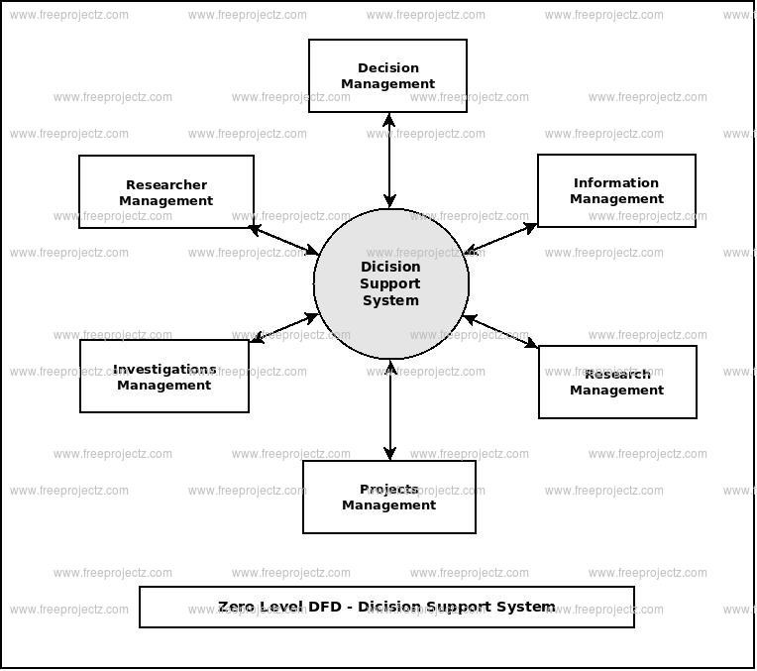

**Decision support system examples**

Organizations use decision support systems in several different contexts, including the following:

• **GPS routing:-** GPS route planning is an example of a typical DSS. It compares different routes, taking into account factors such as distance, driving time, and cost. The GPS navigating system also enables users to choose alternative routes, displaying them on a map and providing step-by-step instructions.

• **ERP dashboards:-** ERP (enterprise resource planning) dashboards can use a decision support system to visualize changes in production and business processes, monitor current business performance against set goals, and identify areas for improvement. ERP dashboards let business owners see a snapshot of their company's most important numbers and metrics.

• **Clinical decision support system:-** A clinical decision support system (CDSS) is a software program that uses advanced decision-making algorithms to help physicians make the best medical decisions. Healthcare professionals often use these to interpret patient records and test results and to calculate the best treatment plan. CDSS in healthcare can help providers identify abnormalities during specific tests, as well as monitor patients after certain procedures to determine if they are having any adverse reactions.

**Information System for Strategic Advantage**

**Information system for strategic advantage**

A strategic information system provides a connection between the demands of the organization and the latest information technology. This tactic helps an organization to get hold of the market by utilizing Information tech to meet its challenging requirements to the continuous variation in the corporate environment. Helps them evolve their business strategy, helps with knowledge management and operations management.

Information system strategy is a critical aspect of an organization’s management decision for its growth, expansion, and supply chain management. Information technology and competitive intelligence can work wonders for a business. The integration of the data system and its function within the organization can be handled easily by enabling open access and the use of management systems. Besides that, it also enables the classification of different opportunities for the use of information systems for different strategies. It gives the surety that only useful resources or the use of resources which are less are allocated to the applications and to use the scarce resources sustainably and have a better impact factor. The System Information Strategy ensures that the Information system functions accordingly and supports the business goals and objectives of the organization at the different levels.

There are several instances of strategic planning which have helped the organizations to help create and sustain the resources in this competitive market over the past years and have allocated several effective benefits and simply continued to provide for the survival of these organizations which have used these systems. These systems are often termed as ‘strategic concepts of the organization.’ To give the maximum performance of the firms financially in a fluctuating market, the correlation between Strategic Management and Information systems is significant fundamentally. Understanding of management information system is equally helpful & an asset to the organization.

INFORMATION SYSTEM FOR STRATEGIC ADVANTAGE:-

1. Strategy: Strategy is the determination of the basic long-term purpose and objectives of an enterprise and the adoption of courses of action and allocation of resources necessary for carrying out these goals.

2. Strategic role of Information System: Strategic role of an Information System involves using to development of products, services, and capabilities that give a company major advantages over the competitive forces it faces in the global marketplace. • Information systems that promote business innovation, improve operational efficiency.

3. Competitive Strategies:

* Cost leadership strategies: Become a low-cost producer of products and services Find ways to help suppliers or customers reduce their costs
* Differentiation strategies: Developing ways to differentiate a firm’s products and services from its competitors Reduce the differentiation advantages of competitors.

4. Innovation strategies: Finding a new way of doing business, entering a new market.

* Growth strategies: expanding into global market diversifying into new products and services integration into related products or services
* Alliance strategies: Establish alliances with customers, suppliers, competitors, other companies.

5. Use of Information System in Business

* Improving business operations: it helps the company to cut costs, improve quality and customer services and develop innovative products for new markets.
* Promoting business innovation: Investment in IT can result in the development of unique products and services or processes.

6. Locking in customers and suppliers: Interorganizational IS, EDI, automatic inventory replenishment system

* Creating switching costs: make customers dependent on the continued use of innovative IS.
* Raising barriers to entry: discourage competitors from entering a market